MOBILE COMPUTING AND NETWORKS

NANSUBUGA SHARIFAH REG:2022-B072-21338

ONGOM ERIC REG:2022-B072-22231

Versioning, Documentation **and Reporting**

**Project Objectives**

Main goals of the eBook application.

The main goals of the eBook application are to provide users with a convenient and immersive reading experience on their mobile device.

Accessibility: Enable users to access a wide range of digital books conveniently from their smartphones.

User Experience: Enhance reading experience through features like customizable fonts, adjustable brightness, and intuitive navigation.

Offline Access: Enable users to download eBooks for offline reading, ensuring accessibility even without an internet connection.

Personalization: Provide personalized recommendations based on users' reading history and preferences to enhance engagement and satisfaction.

**Methodology**

Choice of Programming Languages and Technologies:

Java: Utilized Java as the primary programming language for Android app development due to its robustness, compatibility with Android SDK, and extensive community support.

XML: Leveraged XML for designing user interfaces (UI) within Android Studio, as it provides a structured markup language for defining UI elements and layouts.

**Design Process with Figma**

Figma: Employed Figma as a collaborative design tool to create high-fidelity wireframes, mockups, and prototypes of the eBook application's UI.

Collaborative Design: Figma facilitated collaboration among group members by allowing simultaneous editing and real time feedback, streamlining the design iteration process.

Efficient Development: Figma designs served as a blueprint for UI implementation in XML, enabling developers to translate design elements accurately into code while maintaining design consistency.

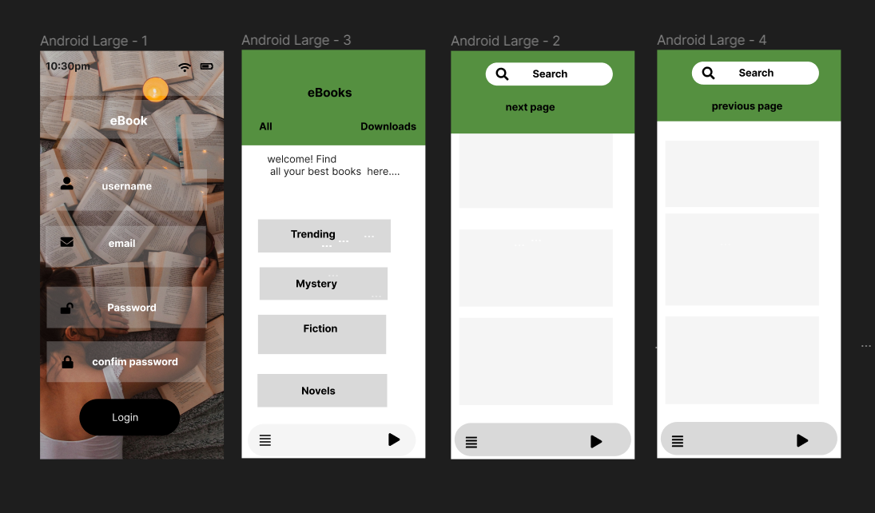

**Design Decisions**

User Interface Design Principles:

Consistency: Ensure consistency in UI elements, layout, and interaction patterns throughout the application to provide a cohesive user experience.

Clarity: Prioritize clarity and simplicity in design to make navigation and interaction intuitive for users.

Utilization of Figma for Design:

High Fidelity Mockups: Opted for high fidelity mockups in Figma to visualize the final look and feel of the eBook application, incorporating detailed UI elements, typography, and color schemes.

Interactive Prototypes: Create interactive prototypes in Figma to simulate user interactions and demonstrate the flow of the application, allowing for early feedback and validation of design decisions.

Adaptation to Android Design Guidelines:

Material Design: Adhere to Android's Material Design guidelines to ensure that the eBook application's UI is visually appealing, consistent with other Android apps, and optimized for usability across different devices and screen sizes.

Integration with Development Workflow:

Alignment with Development Timeline: Coordinate design decisions with the development timeline to ensure that UI designs are implemented efficiently within the Java and XML codebase.

**Implementation Details**

Programming Language:

Java: Utilized as the primary programming language for Android app development due to its compatibility with the Android SDK and extensive community support.

User Interface Design:

XML: Used for designing user interfaces (UI) within Android Studio. XML provides a structured markup language for defining UI elements and layouts.

Integrated Development Environment (IDE):

Android Studio: Chosen as the primary IDE for Android app development. Android Studio provides a comprehensive set of tools for designing, developing, debugging, and testing Android applications. It offers features such as code completion, debugging tools, and integration with the Android SDK.

Dependency Management:

Gradle: Leveraged as the build automation tool and dependency management system for the eBook application. Gradle simplifies the process of managing project dependencies, building, and deploying Android apps.

**Results**

Alerts and notifications to inform us about test results.

Analyze test failures promptly to identify the root cause of the issues.

Prioritize fixing critical issues that affect the core functionality of the application.

Continuous Improvement:

Use test results as feedback to continuously improve the testing procedures and application quality.

Conduct retrospectives to reflect on testing practices, identify areas for improvement, and implement necessary changes.

Encouraged collaboration between group members to foster a culture of quality and continuous improvement.

By effectively managing test results, you can identify issues early, prioritize fixes, and ensure the overall reliability and quality of your application.

**Executive Summary**

The eBook application is a mobile application developed for Android devices using Android Studio as the primary development environment. The application aims to provide users with a seamless experience for discovering, purchasing, and reading books on their mobile devices. The development process involved the use of XML and Java for coding the application's frontend and backend functionality, respectively. Figma was utilized for designing the application's user interface (UI) and prototyping its various screens. Key Features used include: Search Functionality; Users can easily search for specific books using keywords, titles, authors, or genres, ensuring a convenient and efficient browsing experience, Book Catalog: The application offers a comprehensive catalog of books across various genres, allowing users to browse and explore a wide range of titles.

User Authentication: The application provides secure user authentication mechanisms, enabling users to create accounts, sign in securely, and manage their profiles and preferences. Book Preview and Purchase: Users can preview book details like price. Reading Experience: The application offers a user-friendly reading interface with customizable settings such as font size, background color.

Development Technologies:

Android Studio: The official integrated development environment (IDE) for Android app development, providing powerful tools and features for building, debugging, and testing Android applications.

XML: Used for designing the application's UI layout and defining interface elements such as buttons, text fields, and navigation components.

Java: Employed for implementing the application's backend logic, including data processing, user authentication, and interaction with external APIs and services.

Figma: Utilized for creating high-fidelity UI designs, wireframes, and prototypes, facilitating collaboration among designers, developers, and stakeholders throughout the design and development process.

Highlight the main achievements, challenges, and outcomes of the project.

**Conclusions**

By utilizing these technologies and tools, the development team was able to efficiently design, develop, test, and document the eBook application, ensuring its quality, usability, and maintainability throughout the development lifecycle. The development of the book application demonstrates a successful integration of technologies such as Android Studio, XML, Java, and Figma to create a feature-rich and user-centric mobile application. By leveraging these technologies and implementing key features such as book catalog, search functionality, secure authentication, and personalized recommendations, the application aims to provide users with an immersive and enjoyable reading experience on their Android devices.